1. Search Autodesk.com in google search bar and select following site.

<https://www.autodesk.com>

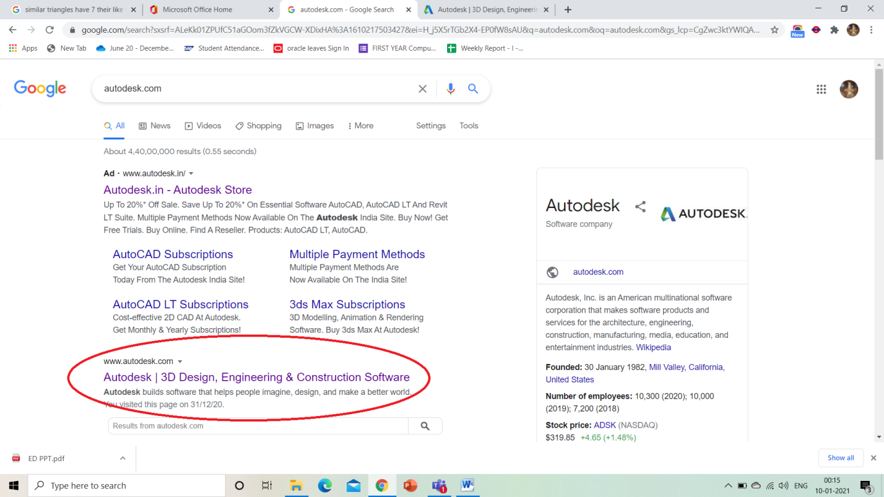

1. Click on free trials

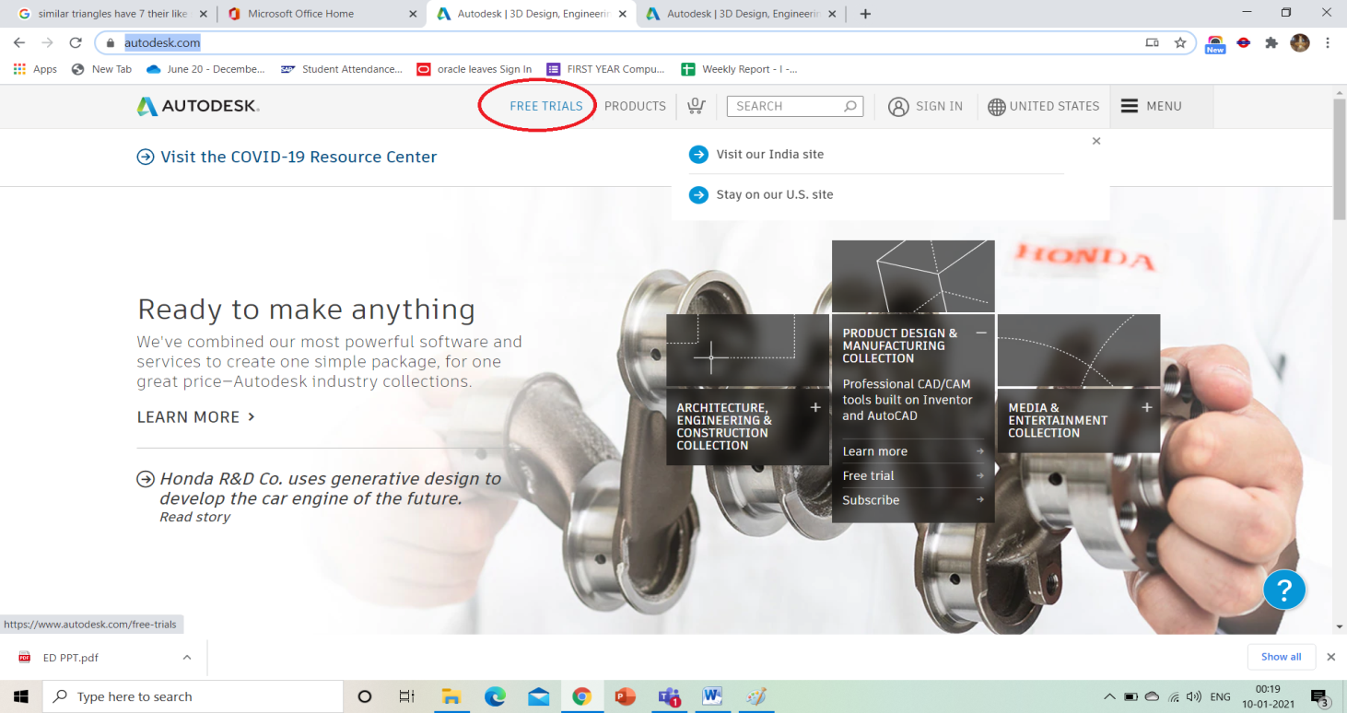

1. Unlock student access by clicking get started option

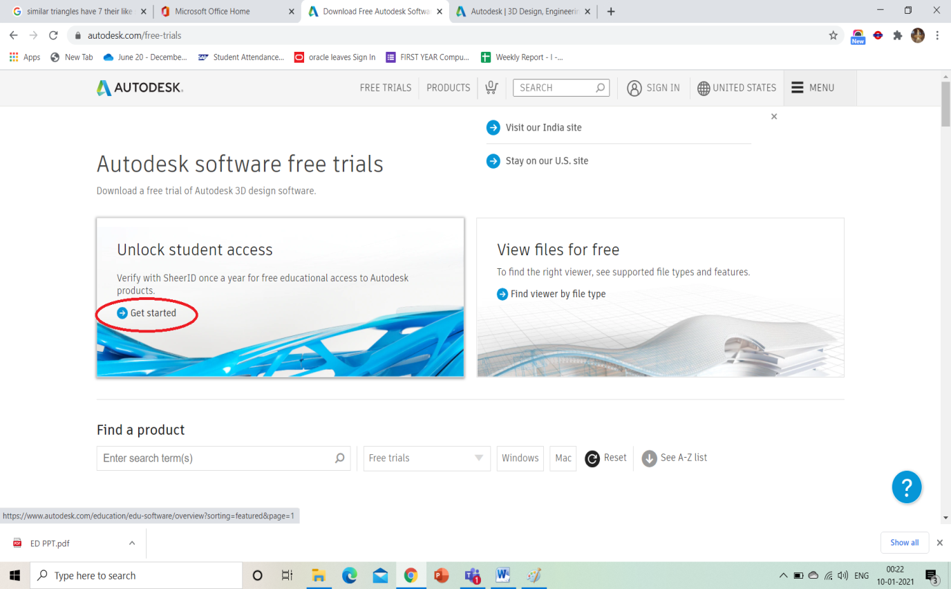

1. Click on get started.

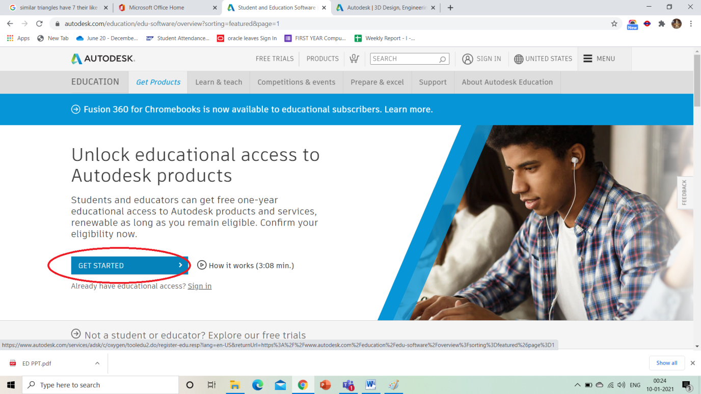

1. Following screen appears :

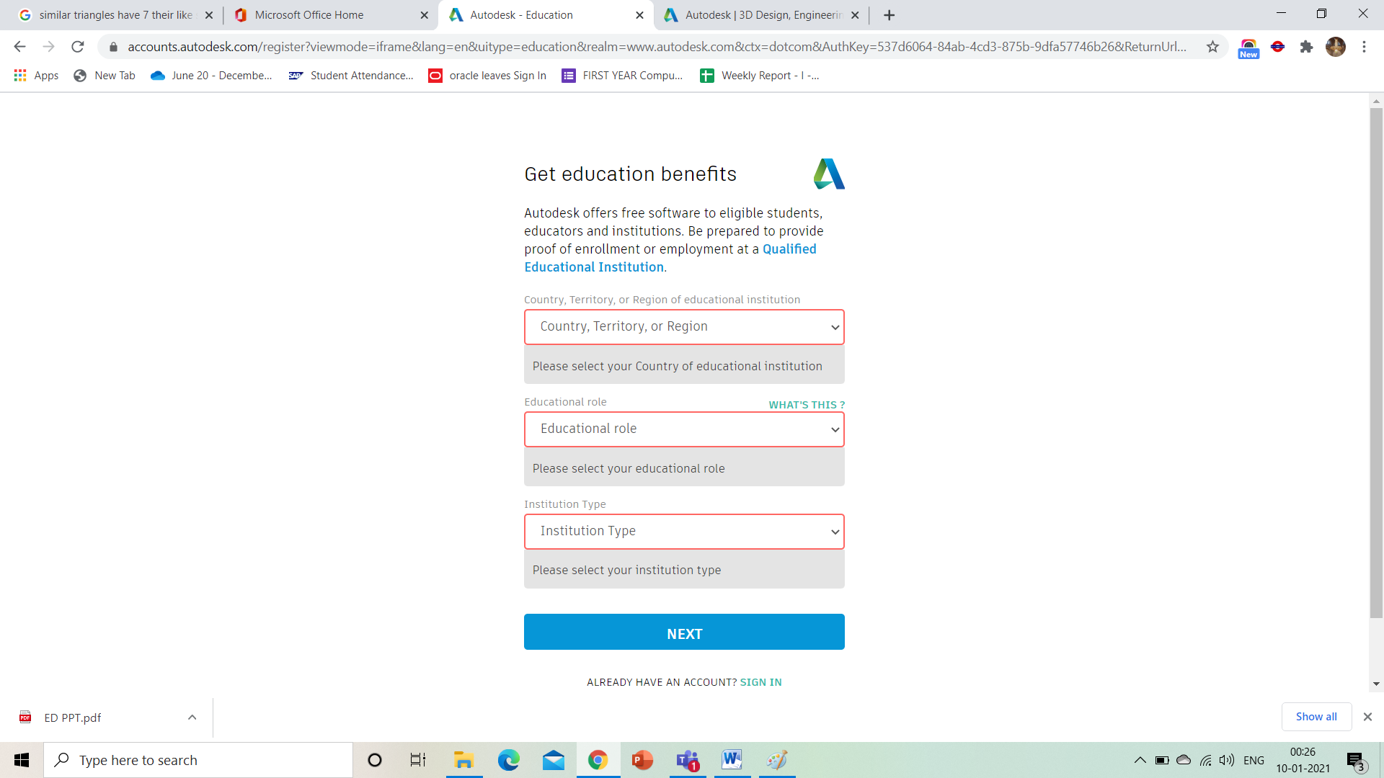

1. Select following option for each field :

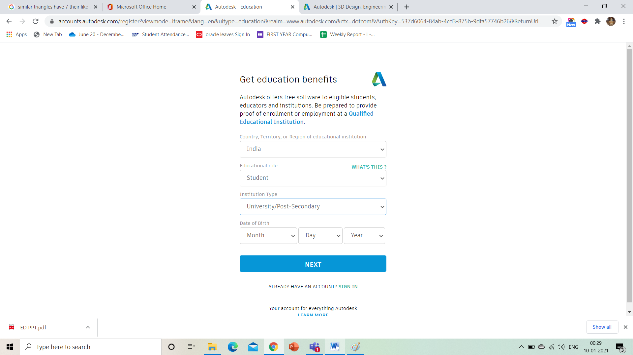

1. Create account with autocad:

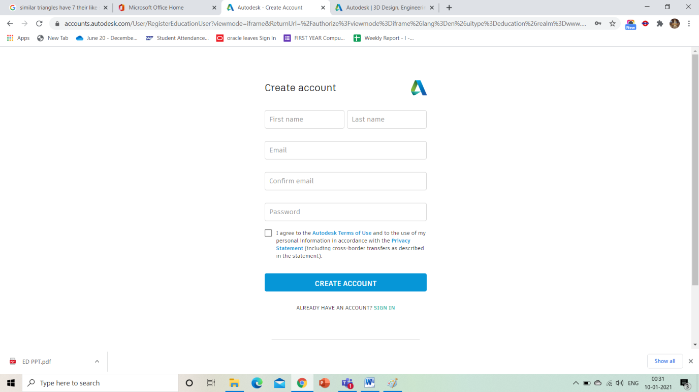

Personal email id

1. Verification process :

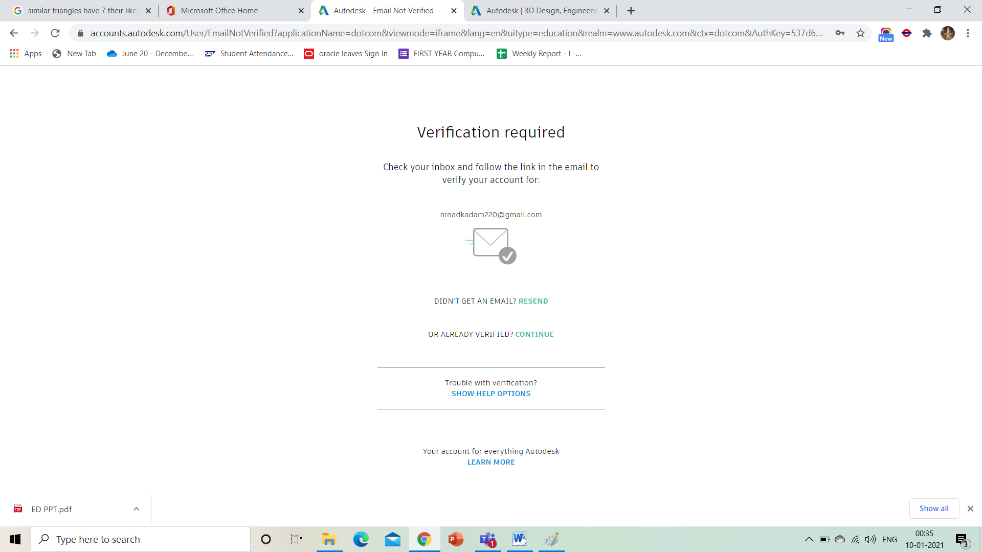

1. You will receive verification option on provided email id. Do the necessary verification steps.

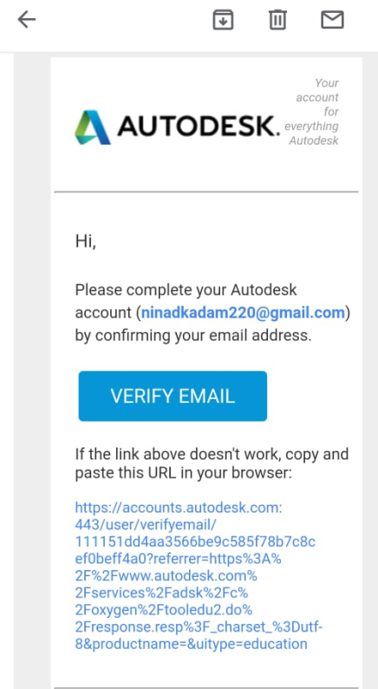

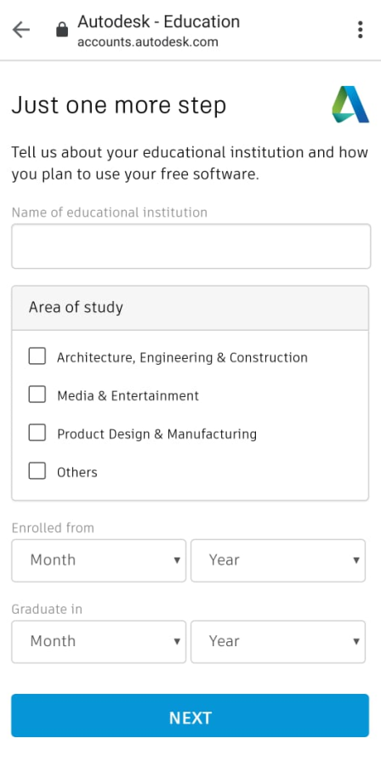

June 2024

Nov 2021

Select this option

Enter college name i.e. shri bhagubhai maftlal polytechnic

1. After verification you will receive following message

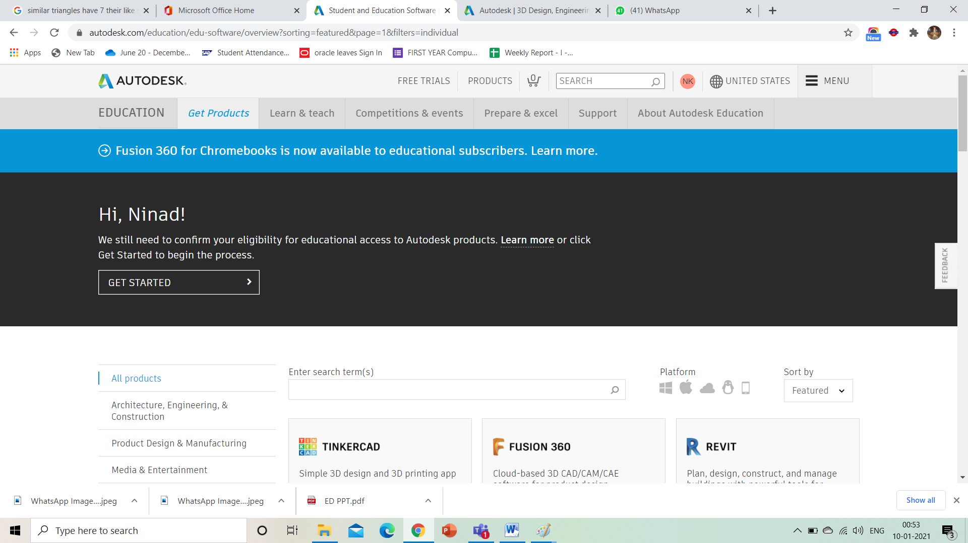

1. Scroll down the window and click on following option:

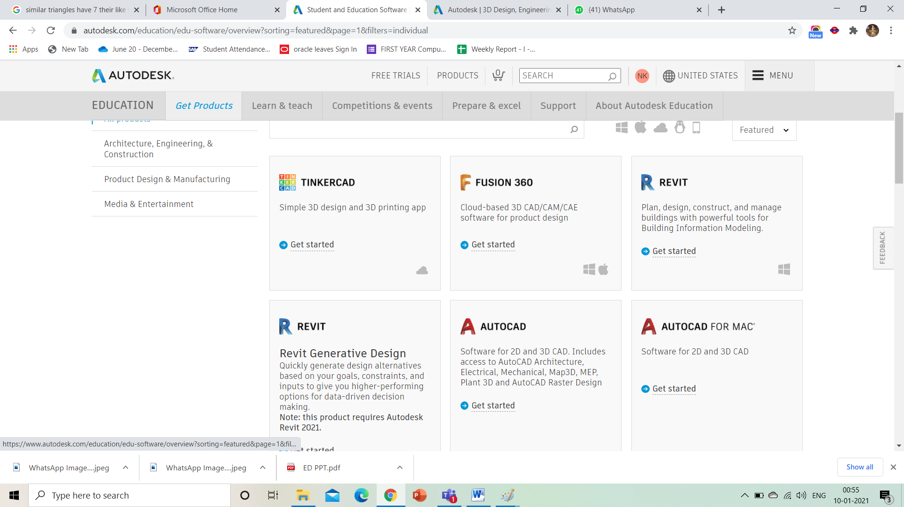

1. Confirm your details and click on confirm button:
2. Upload admission confirmation letter (pdf file) and click on submit button.

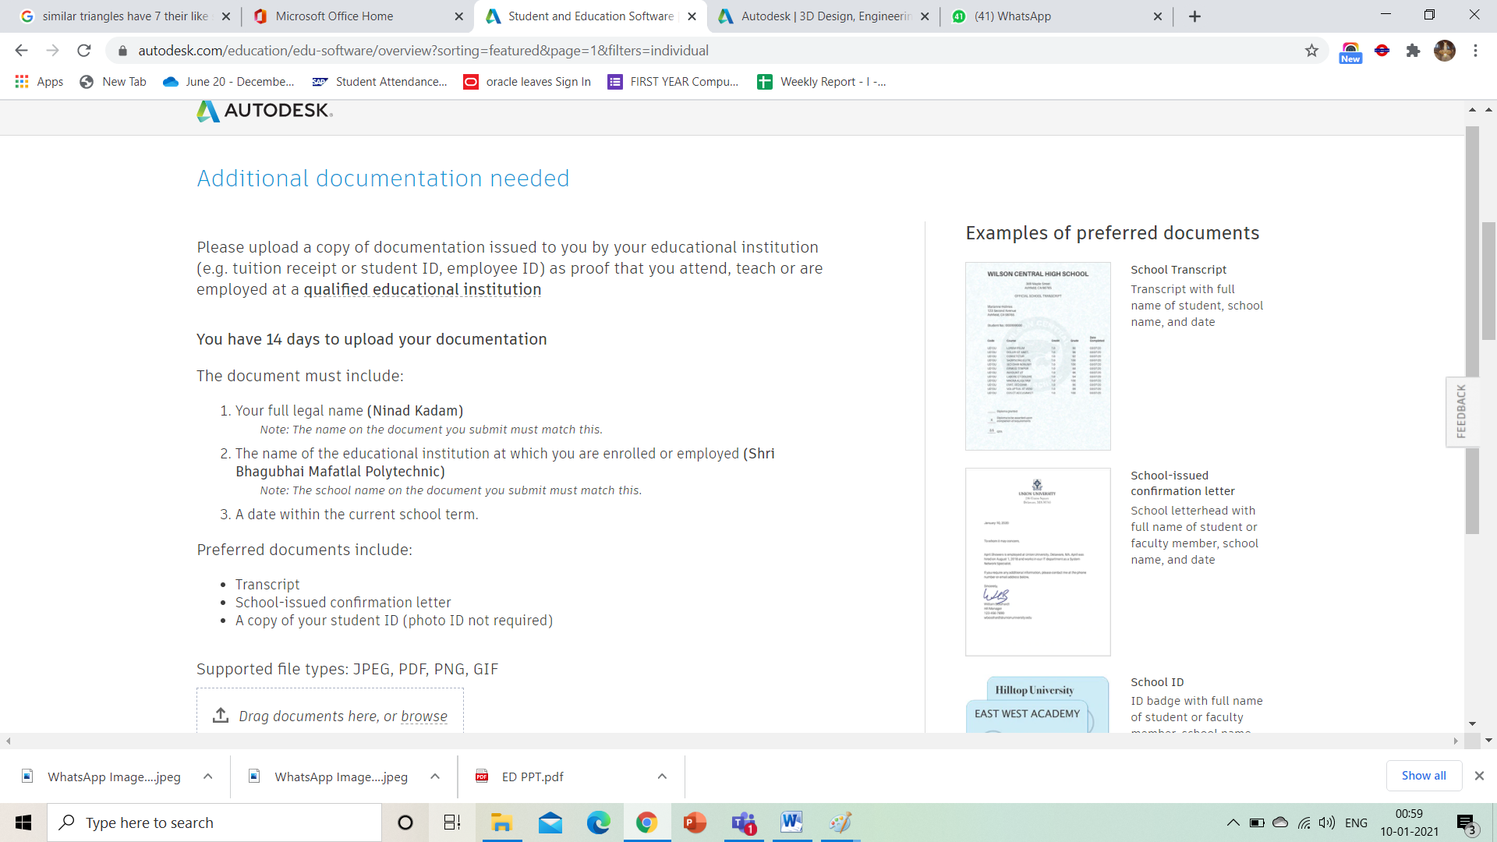

1. They will you revert you on your provided emai id.
2. Once you get access of 1 year just click on following option

